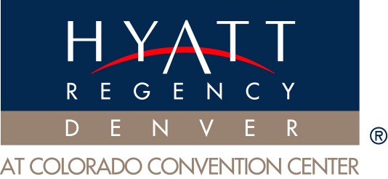 | TABLE-TOP EXHIBITOR FORM | AASV  March 2012  Denver, CO

ACCOUNT AUTHORIZATION – I hereby agree that all charges incurred for the booth/table I am holding at the Hyatt Regency Denver will be charged to my credit card as noted on this form.
Full payment by Check or Credit Card, including tax, is due in advance.
Purchase orders or C.O.D are not accepted.
Cancellations received less than 24 hours prior to exhibit load-in will be charged a minimum of a one-day rate.
Credit card # | Expiration Date:
Signature:
Connect Date & Time: | Event Room:
Disconnect Date & Time: | Booth #:
A photocopy of the front and back of the credit card is required to process the order

ELECTRICAL:
(please enter quantity required)
Powerstrip & Cord Package: $130.00, One Time Charge, Plus sales tax | Quantity:
Rates quoted include installation of service to booth, current used, proper fusing & removal upon conclusion of conference.

TELECOM:
(please enter quantity required)
DID Line for Fax or Credit Card Machine $75.00, per day, Plus sales tax | Quantity:
Rates quoted include installation of service to booth and removal upon conclusion of conference.
Rates do not include access or call charges

INTERNET:

Please contact Luke Lehman with Swisscom Hospitality Services: 303-486-4879

AUDIO VISUAL:

Please contact Karen Veith with Swank Audio Visuals: 303-486-4717

PACKAGES:
All boxes delivered to the hotel will be assessed an in-bound and out-bound handling fee based on size of the box.
Prices: $10.00 for boxes; Display cases/Hard cases on wheels: $35.00
Pallets: $200.00

The Hotel is not responsible for perishable items or out-going shipments upon conclusion of the conference.
The Hotel must be advised in advance of any shipments weighing over 100 pounds.
A labor charge will be assessed if the Hotel’s staff is required to unload/load vehicles and/or moving items during the conference.

All shipments should be received no sooner than 2 days prior to the conference.

Packages should be addressed accordingly:
Hyatt Regency Denver
Hold For: Guest Name & Arrival Date, Organization Name
Convention representative Name: Debbie Famiglietti
650 15th Street
Denver, CO 80202
(Box 1 of 2; Box 2 of 2 etc.)
FedEx Office will be available for out going shipments (Lobby Level).

POLICIES AND PROCEDURES:
Please note the Hotel cannot supply water or compressed air. Fire codes strictly enforced.

All materials and equipment are furnished on a rental basis, and remain the property of the Hotel and/or its Partners.
Unreturned items will be charged at the retail price plus 50%.

OTHER RESTRICTIONS APPLY, PLEASE CONSULT THE CS CONTACT BELOW
**ORDERS PLACED THE DAY OF THE EVENT WILL INCUR ADDITIONAL FEES**

**ALL REQUESTS MUST HAVE COMPLETED BILLING INFORMATION BEFORE SERVICE IS RENDERED**

